5th Grade Math Syllabus

Teacher: Kelly Marino Phone: 817-299-2700
Team: Juneau
Conference Period: 1:15-2:00 Email: kellymarino@misdmail.org
Website: kellymarino.weebly.com

Year at a Glance:

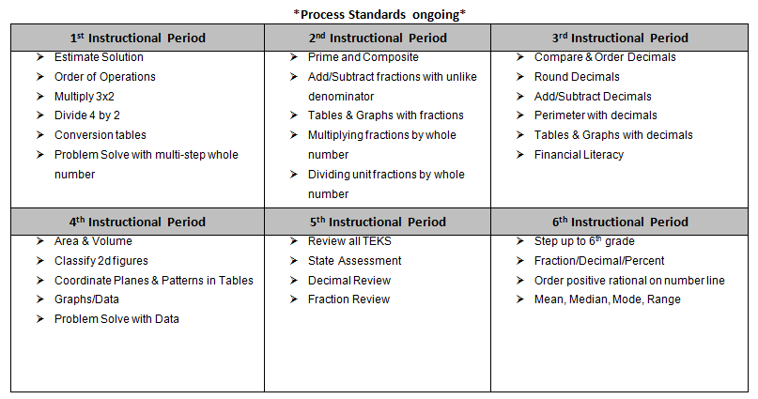
Text:

We will be using alternative resources in lieu of a textbook this year. Students will be required to keep a math journal to record their notes and learning. This journal will serve as a valuable resource and tool for students as they progress through the course objectives. Motivation Math workbooks will also be issued to each student as a required text.

Goal:

To build and strengthen all students’ understanding of Math so that it will serve as a foundation for their future.

Requirements:

- Positive Attitude
- Active Class Participation
- Group Collaboration
- Ongoing Assessment (Exit Tickets, Quick Checks, CBAs)
- Weekly Homework Assignments

(Note: This excludes Thanksgiving Break,Winter Break, and Spring Break)

Course Calendar/Schedule:

- Curriculum Based Assessments (CBAs) will take place after each instructional unit.
- Math STAAR Test: Tuesday, March 28, 2017

Attendance:

Regular school attendance is essential for a student to make the most of his or her education—to benefit from teacher-led and school activities, to build each day’s learning on the previous day’s, and to grow as an individual. Absences from class may result in serious disruption of a student’s mastery of the instructional materials; therefore, the student and parent should make every effort to avoid unnecessary absences.

Absences
In the event that a student must be absent, they will need to make up their assignments or tests after excused absences. Students will have the same number of days they were absent to make up work. Students should consult with the teacher after an absence to identify any work that needs to be completed.

AVID Agenda/Planner:

Students will be expected to write in their agenda on a daily basis. Students will use this tool to keep track of their daily learning, homework, events, and keep communication going between school and home. Parents will be expected to sign/initial the agenda.

A binder will be set up in class and will be checked periodically to ensure that it is organized. Please refrain from taking anything out of the binder, unless it is noted to be removed.

Available Support Services:

- Many resources will be available to support student learning. Students are encouraged to make use of the resources in the classroom, library, and via technology offered in order to further assist understanding.

- Intervention classes will offer support during the school day for students based on their needs.

- Tutoring before or after school will also become available as student needs arise. Students will need to arrange a time to come in for these services with their teacher prior to the day they plan to attend.

Grading Policies:
Grading Scale
Teachers shall determine student progress using a grading scale of 0-100.
- 90-100 =A E = Excellent
- 80-89 = B S = Satisfactory
- 70-79 = C N = Needs Improvement
- Below 70 = Failing U = Unsatisfactory
- I = Incomplete (“I” is not an academic grade, but indicates incomplete work.)
Math will have a minimum of 10 grades each 6 weeks.

Grade Categories
Language Arts, Mathematics, Science, and Social Studies
- 50% - Daily Assignments/Quizzes
- 40% - Major Tests/Projects*
- 10% - Homework
*District Curriculum-Based Assessments (CBAs) are calculated as part of the Major Grades/Projects category.
Late Work
Teachers will accept late work:
- 1 class day late – grade may be reduced up to a maximum of 15 points
- 2 class days late – grade may be reduced up to a maximum of 30 points
- 3 class days late – grade may be reduced up to a maximum of 50 points
Test Retakes
Students who fail a major test/assessment (below 70%) will be allowed to retake or correct for a maximum grade of 70%. All retakes or corrections should be completed within 3 days, but they must be completed prior to the end of the grading period. Students are encouraged to attend tutorials.
Semester Grades
Semester grades are computed by averaging the numerical grades recorded for each of the three grading periods within the semester. The three grading periods will equal 100% of the student’s grade (33.3% per grading period). Credit is awarded at the end of the academic year.
No semester exams are administered at the intermediate level.
Academic Dishonesty
A student found cheating, or aiding in cheating, will receive a grade of zero on the assignment and the teacher will contact the parent. Cheating will include being in possession of another student’s assignment, with or without that students’ knowledge.

